PROJECT REPORT
TROVE CART – ECOMMERCE APPLICATION

SUBMITTED BY:
ADITYA. G (71762233001)
BHAVATHARANI. C (71762233004)
VISHNUVARTHAN. N (71762233059)

SUBMITTED TO
DR. V. SAVITHRI
ASSISTANT PROFESSOR
DEPARTMENT OF COMPUTING



COIMBATORE INSTITUTE OF TECHNOLOGY

(GOVERNMENT AIDED AUTONOMOUS INSTITUTION)
COIMBATORE – 641 014

TROVE CART

- INTRODUCTION :
The rapid growth of the e-commerce industry has created an immense demand for innovative and user-friendly platforms. In response to this need, the project "Trove Cart" aims to provide a cutting-edge e-commerce application that redefines the online shopping experience. Developed by us , this project seeks to address various challenges in the e-commerce domain while offering a seamless and feature-rich platform for users

- PROBLEM STATEMENT :
Despite the proliferation of e-commerce platforms, there remain several pain points and challenges that users encounter during their online shopping journeys. Trove Cart is designed to tackle these issues head-on, offering solutions that enhance user satisfaction, streamline operations, and set a new standard for e-commerce applications. The specific problem areas that Trove Cart aims to address include:
- User interface and experience : Many e-commerce platforms suffer from cluttered and confusing interfaces, leading to a suboptimal user experience. Trove Cart focuses on delivering an intuitive, aesthetically pleasing, and user-friendly interface to ensure a smooth and enjoyable shopping process.
- Personalization and Recommendations: Existing e-commerce platforms often struggle to provide personalized recommendations, leading to missed opportunities for upselling and cross-selling. Trove Cart incorporates advanced algorithms to analyze user behavior and preferences, offering personalized product recommendations to enhance the shopping experience.
- Security Concerns: With the rising number of online transactions, security concerns such as data breaches and payment fraud have become major issues. Trove Cart prioritizes the implementation of robust security measures, including secure payment gateways and data encryption, to safeguard user information and ensure a secure shopping environment.
- Security Concerns: With the rising number of online transactions, security concerns such as data breaches and payment fraud have become major issues. Trove Cart prioritizes the implementation of robust security measures, including secure payment gateways and data encryption, to safeguard user information and ensure a secure shopping environment.

- OBJECTIVES :
The Trove Cart project aims to achieve the following objectives:
- Develop an e-commerce application with a user-centric design, focusing on simplicity and ease of navigation.
- Implement advanced algorithms for personalized product recommendations, improving user engagement and sales.
- Prioritize security measures to safeguard user data and provide a secure online shopping environment.
- Integrate a robust inventory management system to optimize stock levels and enhance order fulfillment efficiency.
- Ensure mobile responsiveness to cater to the growing trend of mobile-based online shopping.

- ABSTRACT :

- Trove Cart represents a paradigm shift in the realm of digital commerce, offering an innovative and user-centric platform designed to elevate the online shopping experience. This ecommerce application is meticulously crafted to address the inherent challenges faced by consumers and businesses in the contemporary marketplace.
- At its core, Trove Cart prioritizes the enhancement of user experience, recognizing the pivotal role it plays in fostering customer satisfaction and loyalty. Through an intuitive and visually engaging interface, personalized recommendations, and seamless navigation, Trove Cart redefines the shopping journey, ensuring a delightful and tailored experience for every user.
- Security stands as a cornerstone of Trove Cart's design philosophy. Employing robust encryption protocols and secure payment gateways, the application ensures the utmost protection of user data and transactions, instilling trust and confidence in every interaction.
- With a commitment to innovation and a focus on addressing key challenges within the ecommerce landscape, Trove Cart emerges as a trailblazing platform poised to revolutionize online shopping. By amalgamating user-centric design, stringent security measures, and cross-device adaptability, Trove Cart aims to redefine the benchmarks of excellence in the digital commerce sphere.

- LANGUAGES AND PLATFORMS USED :

- Frontend Language: Object oriented programming- Java with Swing concept.
- Backend Language: Database management systems- Oracle.
- Platforms used: Linked in for Posts (All images and animations)

- ACTORS AND RELATIONSHIPS :

ACTORS :
- Customer/User: The primary user of Trove Cart, engaging with the application to browse products, make purchases, manage their profile, view order history, and interact with the interface.
- Administrator/Manager: Responsible for overseeing the overall functioning of Trove Cart, managing product listings, handling orders, moderating user accounts, and ensuring the platform's smooth operation.
RELATIONSHIPS:
- Customer-Application: The core interaction where the customer utilizes Trove Cart to browse, search, select, and purchase products. This relationship involves actions such as viewing product listings, adding items to the cart, proceeding to checkout, and making payments.
- Customer-Vendor: Customers interact indirectly with vendors through Trove Cart. They view products listed by vendors, read product descriptions, check availability, and provide reviews or ratings based on their purchases.

These actors and relationships form the backbone of interactions within Trove Cart, facilitating smooth transactions, user engagement, and platform management. Customizing and refining these relationships according to specific functionalities and user interactions within your application will offer a more tailored representation.

- USE CASE :

New User / Existing User:
Responsibilities:
New User:
Create a new account on the platform by providing necessary information.
Set up a user profile with preferences and contact details.
Existing User:
Log in securely using credentials.
Access personalized features and settings tied to their account.
Admin:
Responsibilities:
Manage and oversee the overall functionality of the Trove Cart platform.
Handle user management, including account verification and moderation.
Oversee product catalog management, ensuring accurate and up-to-date product information.
Monitor and manage collaborative shopping sessions.
Address user issues and provide support.
Access analytics and reports for informed decision-making.
Login Service:

Responsibilities:
Authenticate user credentials during the login process.
Securely manage user sessions and handle session-related functionalities.
Provide error handling and recovery for login-related processes.
Notifications:

Responsibilities:
Send real-time notifications to users regarding collaborative shopping updates.
Notify users of new messages, product suggestions, and changes in the shopping session.
Manage user preferences for notification settings.
Product Management:

Responsibilities:
Oversee the product catalog, including adding, updating, and removing products.
Categorize and organize products for easy navigation.
Implement search, sort, and filter functionalities for users.
Order Management:

Responsibilities:
Handle the processing and management of user orders.
Provide users with order history and tracking information.
Coordinate with the final payment process to confirm and finalize orders.
Final Payment Process:

Responsibilities:
Facilitate the secure and seamless checkout process.
Integrate with payment gateways to process transactions.
Confirm successful payments and update order status.
These actors collectively contribute to the smooth operation of Trove Cart, each playing a crucial role in ensuring a positive user experience, managing the platform's content, handling user interactions, and securing transactions. The collaboration among these actors results in a comprehensive and functional collaborative e-commerce platform.

- USECASE DIAGRAM :

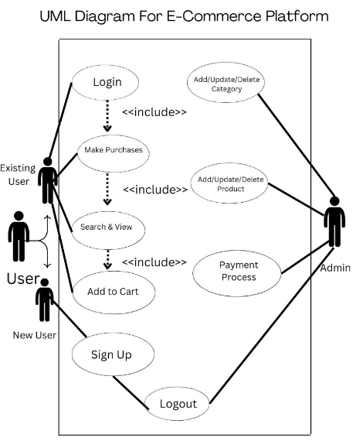
- FUNCTIONALITIES IMPLEMENTED :

- USER REGISTRATION:

Trove cart allows users/ customers to register for their Ecommerce services by letting them to Signup for the first time and then login.

- PROFILE MANAGEMENT :

Trove cart allows users/ customers to view their account details in their My Accounts section, which shows the details of currently logged in user’s details through the Login- signup database.

- PRODUCTS BROWSING:

Trove allows users, the ability to browse through various product categories, search, filter, and view detailed product descriptions.

- CART MANAGEMENT:

Trove allows users/ customers to manage their carts, in which it allows them to add, remove, and modify items in the cart before proceeding to checkout.

- PAYMENT :

Trove allows the users with seamless and secure payment gateway integration for completing purchases.

- UI DESIGN :

- LABELS AND TEXT FIELDS:

Labels to describe data fields or categories. Text fields for input or display of textual information.

- BUTTONS:

Action buttons for triggering operations like generating a report or exporting data. Navigation buttons for moving between sections or pages.

- TABLES:

Tabular data representation using JTable or similar components. Column headers and rows for organizing and displaying data.

- ICONS:

Iconography to represent actions, status, or categories. Icons for export, refresh, print, etc.

- MENUS AND MENU BARS:

Menu bars with dropdown menus for organizing application functionality. Contextual menus for specific actions related to reports.

- DIALOG BOXES:
Modal or non-modal dialog boxes for user interaction. Message boxes for alerts or notifications.
- TABS AND PANELS:

Tabbed panes for organizing content into different sections. Panels for grouping related components or data.

- TOOLTIPS:

Tooltips for providing additional information when hovering over elements. Helpful for explaining icons or abbreviations.

- RESPONSIVE DESIGN:

Design elements that adapt to different screen sizes and resolutions. Ensures a positive user experience across devices.

- COLOR PALETTE:

Consistent color scheme for branding and visual coherence. Use color to highlight important information or actions.

- CLASS DIAGRAMS :

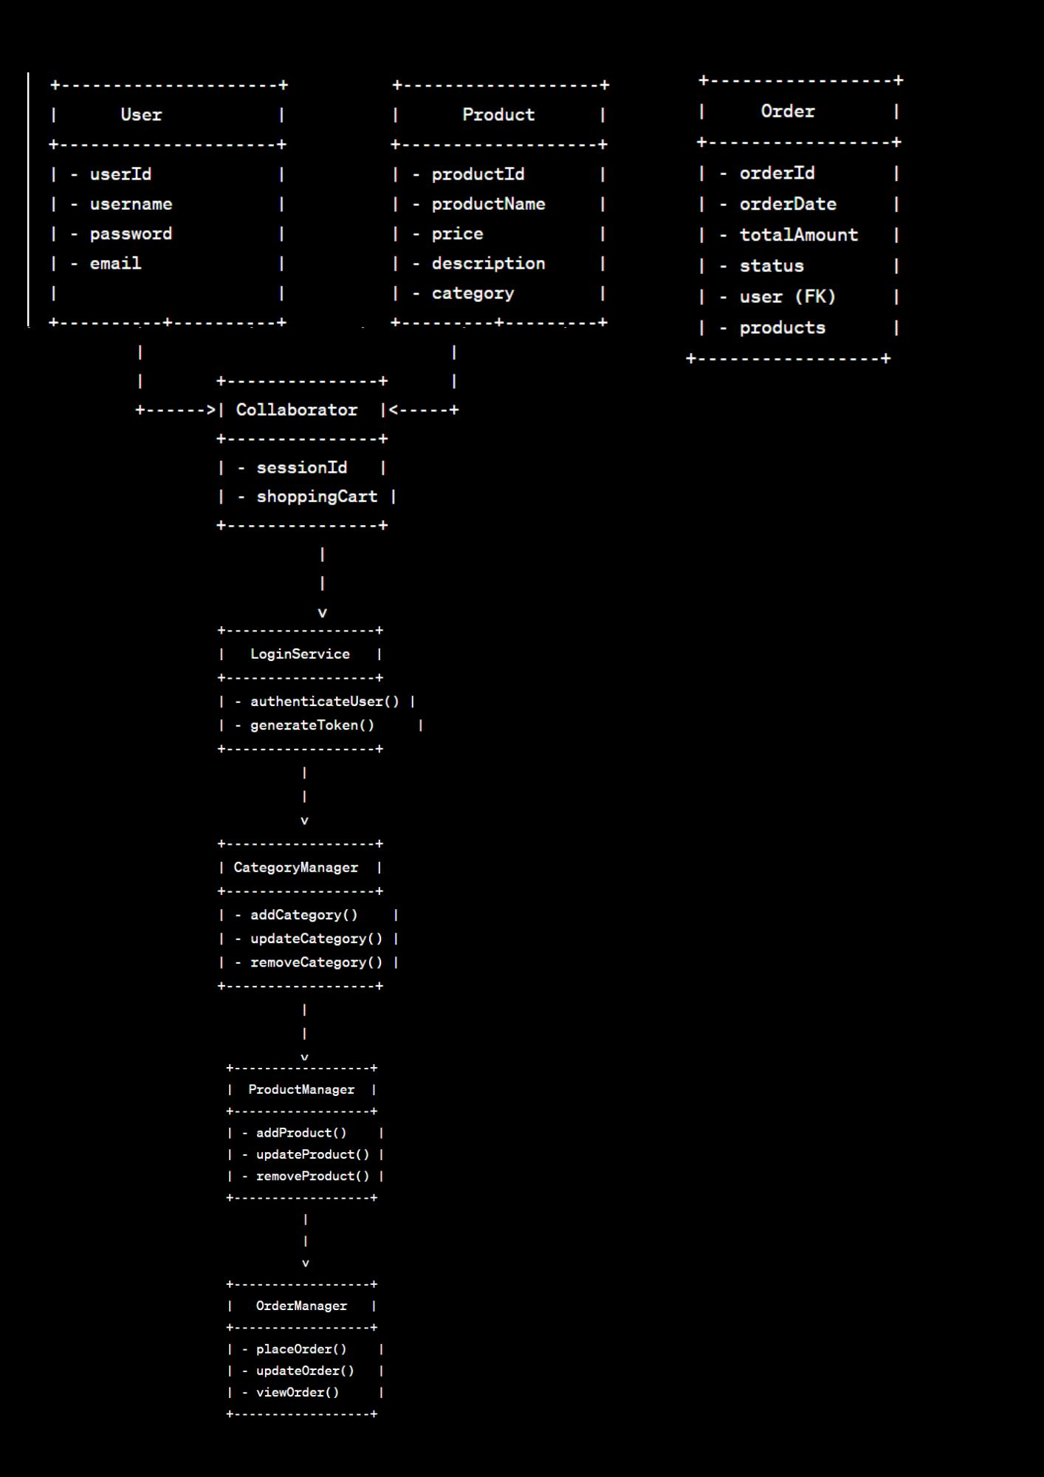

- TROVE CART – APPLICATION GUI PANELS :

An Attractive Welcome page of Trove cart with a warm welcome message along with the Login and Signup functionalities.
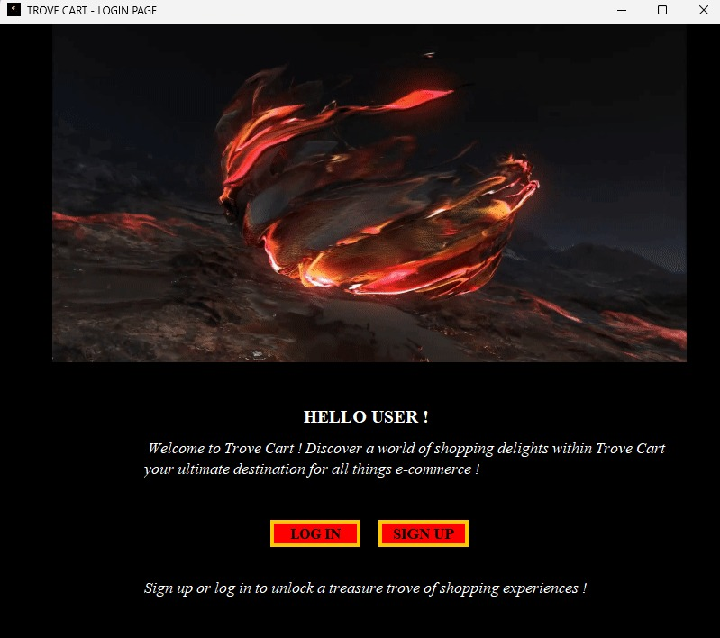

Signup page of Trove cart
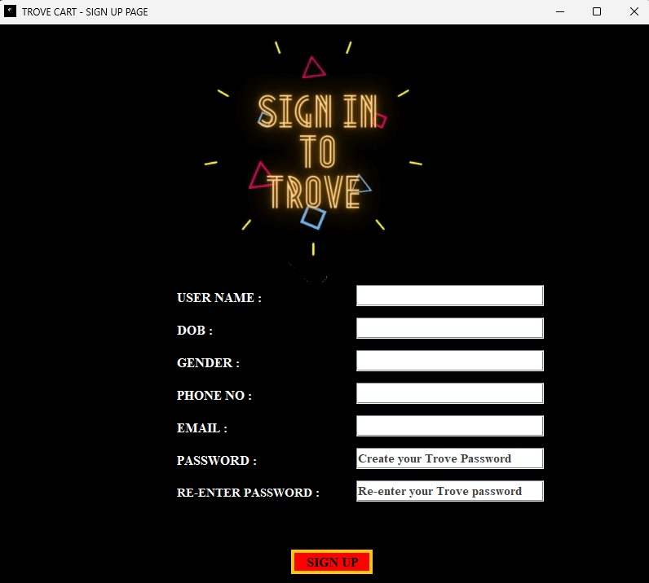

Signup page with functionalities of (passwords must match) matching password.
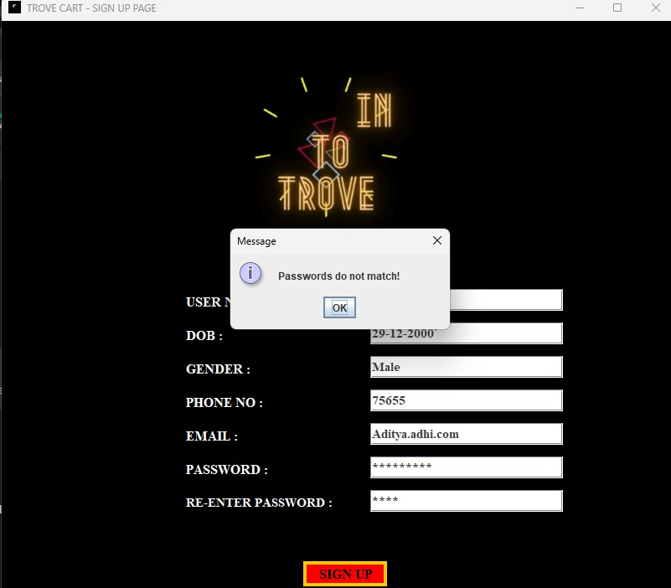
Signup page with phone number must be 10 digits.
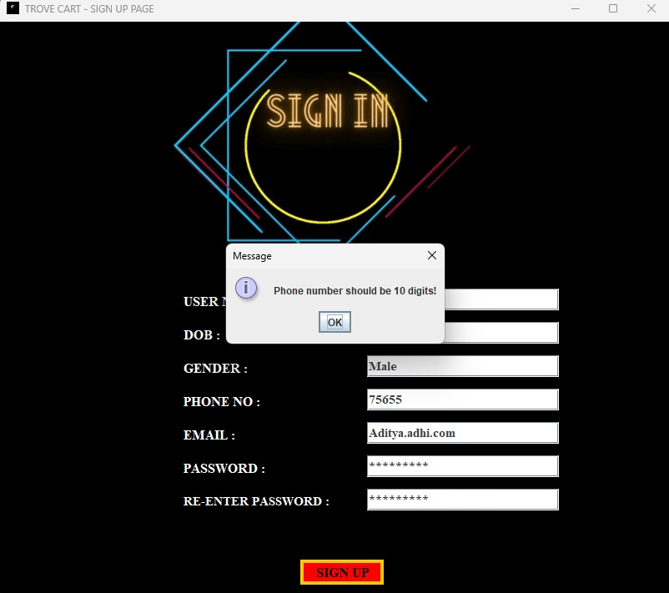

Signup page with email must have the character ‘@’ to proceed with it.
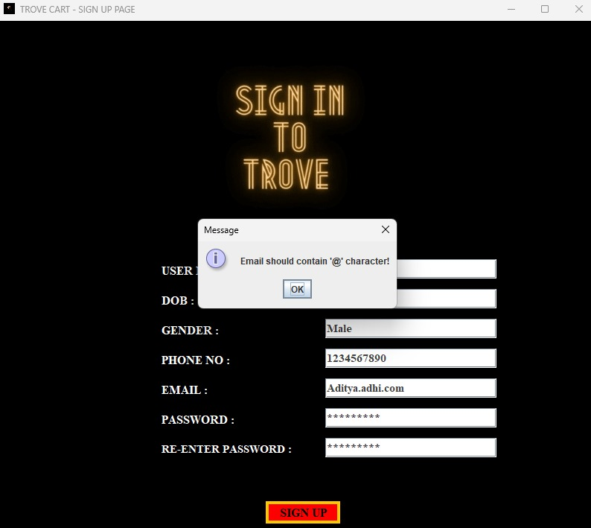
Signup Successful
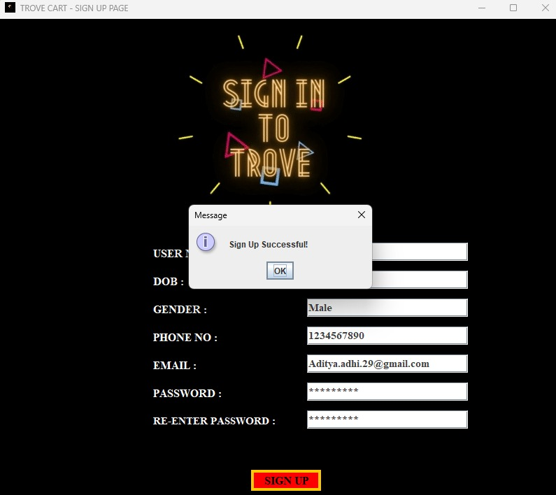
After Signup, it will be redirected to the Address page of our application.
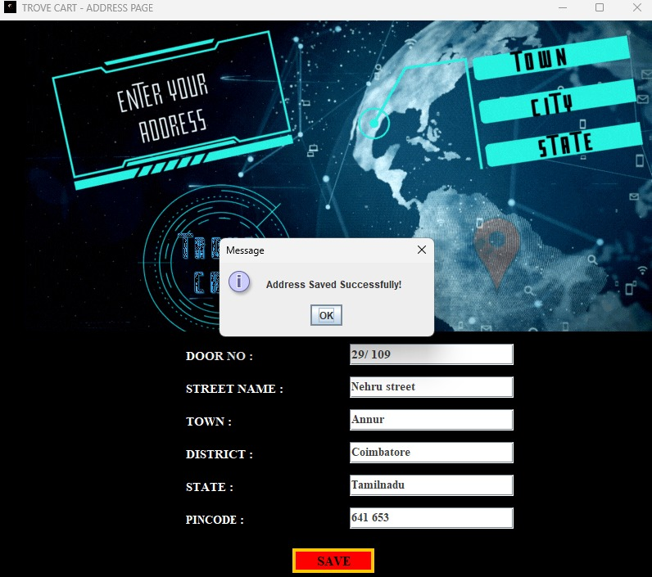
After every successful signup, the user will we welcomed with a warm Welcome message through email they’ve given in here. Here’s an email in an user’s inbox.
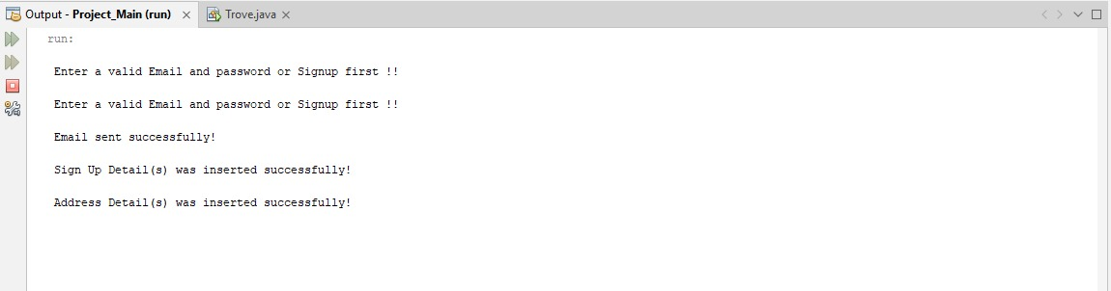
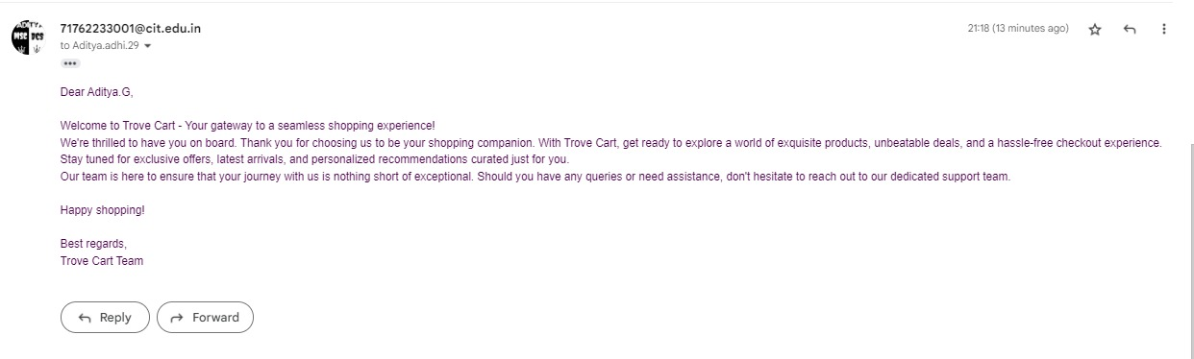
Then the User will be allowed to Login in our Login page.
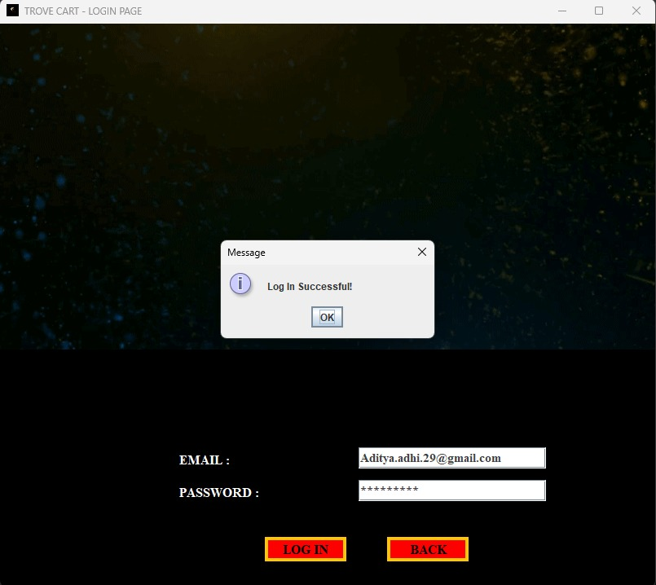
Then the user is directed to the Landing page of our Application.
This is the Landing page of our application (Trove cart )
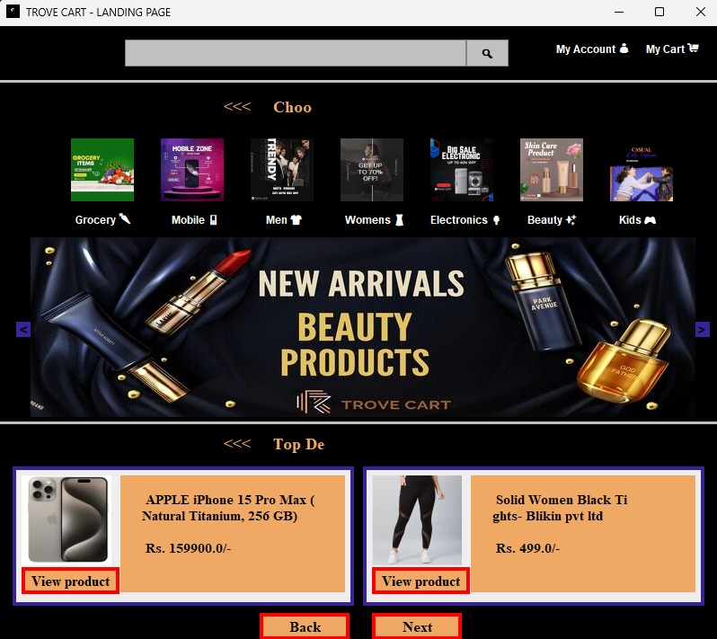
Our Landing page is filled with efficient search bars, Account details, Cart details, categories and today’s deals with a numerous number of products.

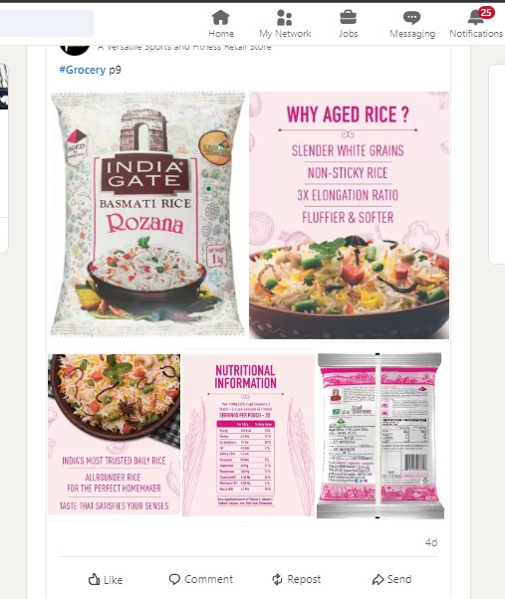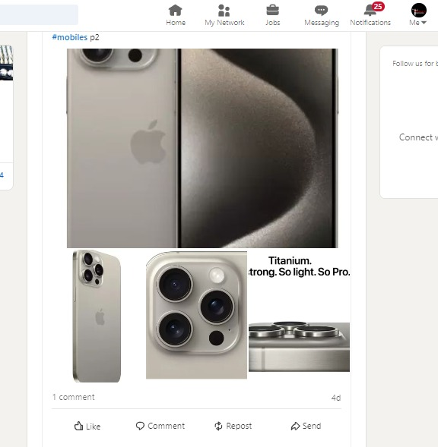
Each and every products are uploaded in our Linkedin profile, using those image links in our database.
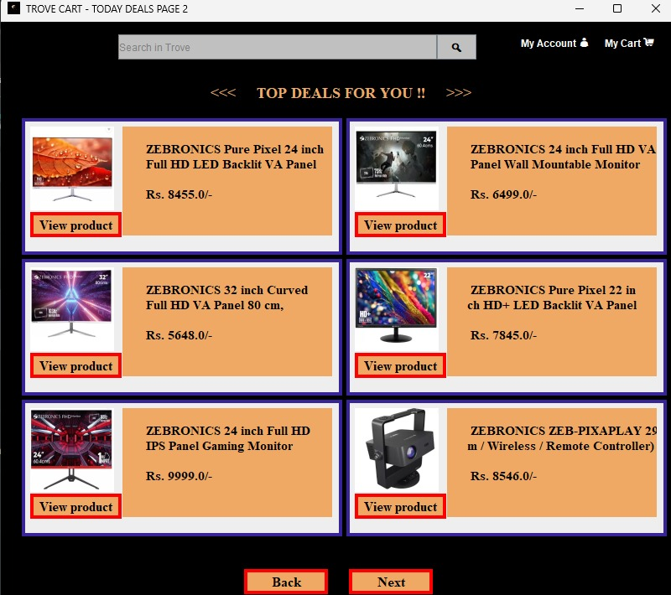

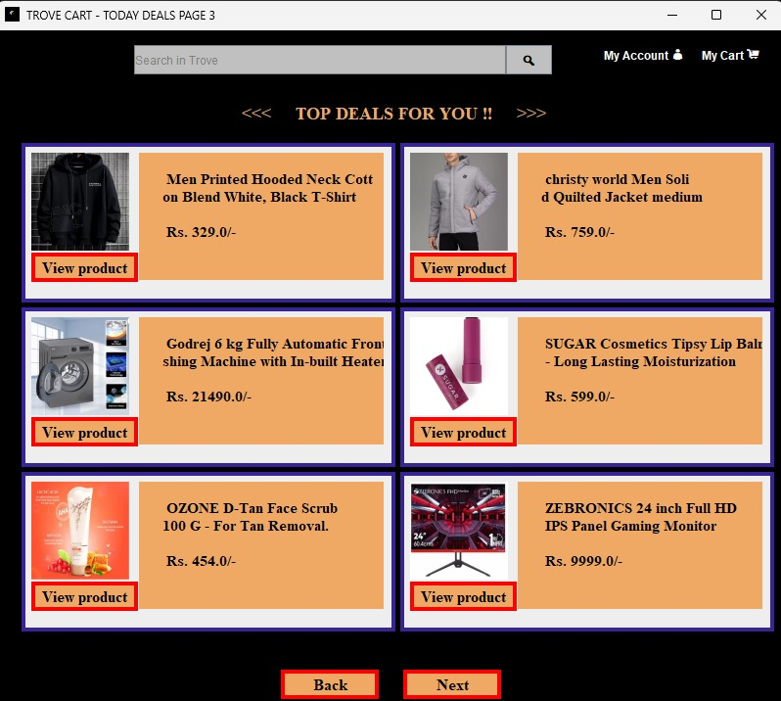

Our application’s Deals page.
Our Application’s Accounts section.
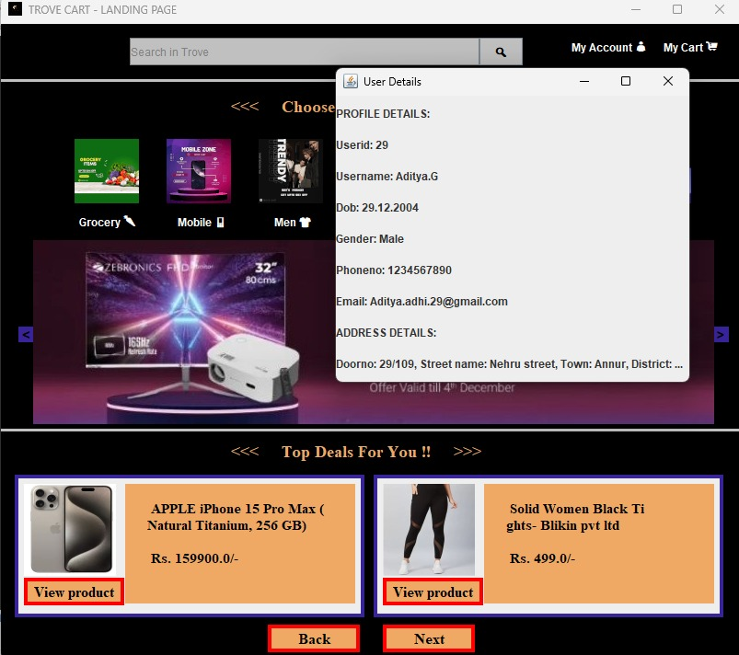

Our Application’s logo in taskbar and titlebar.

Our Application’s Placeholder functions that gets invisible on typing inside the password field and search field.



Our Application’s vast category section for all.

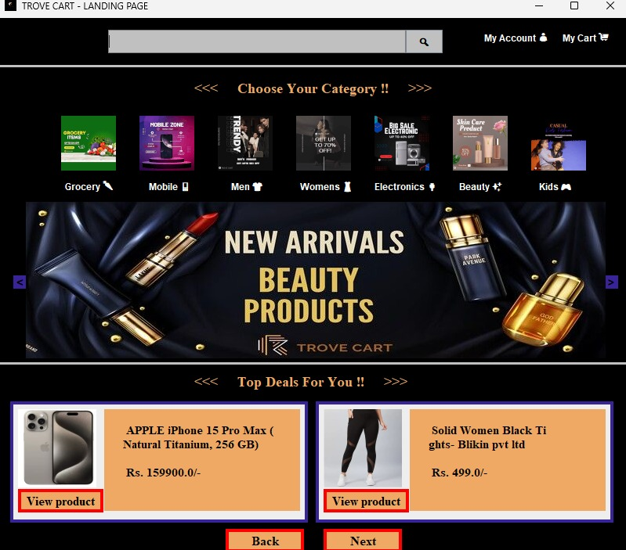

Products overview and cart management
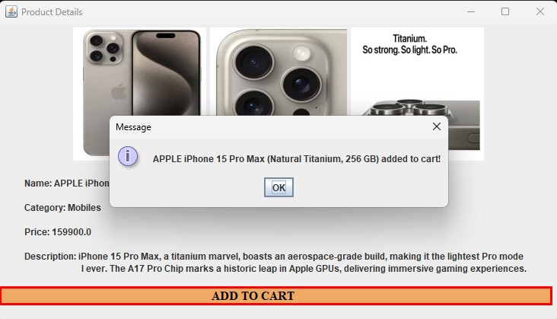
Secured payment action

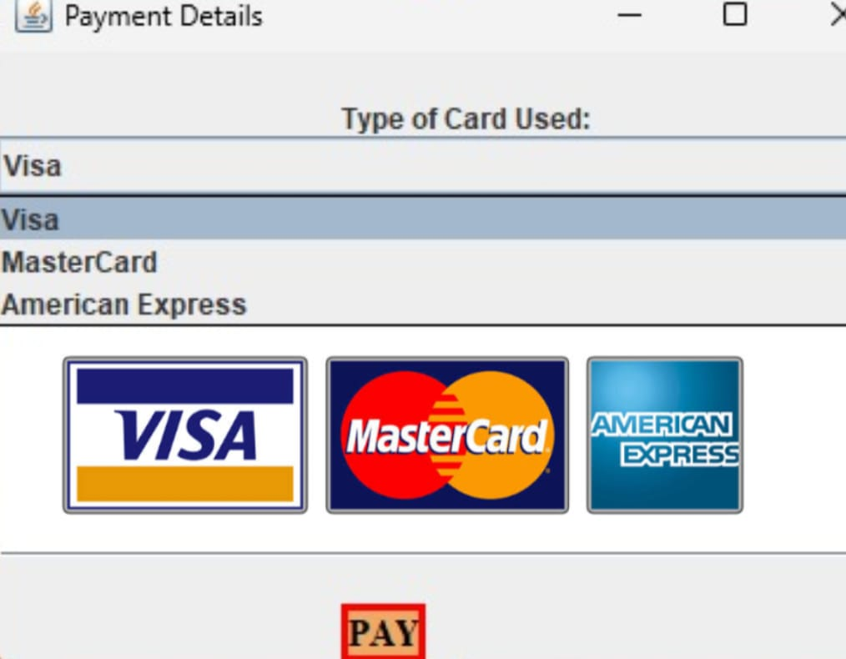
Order successful.

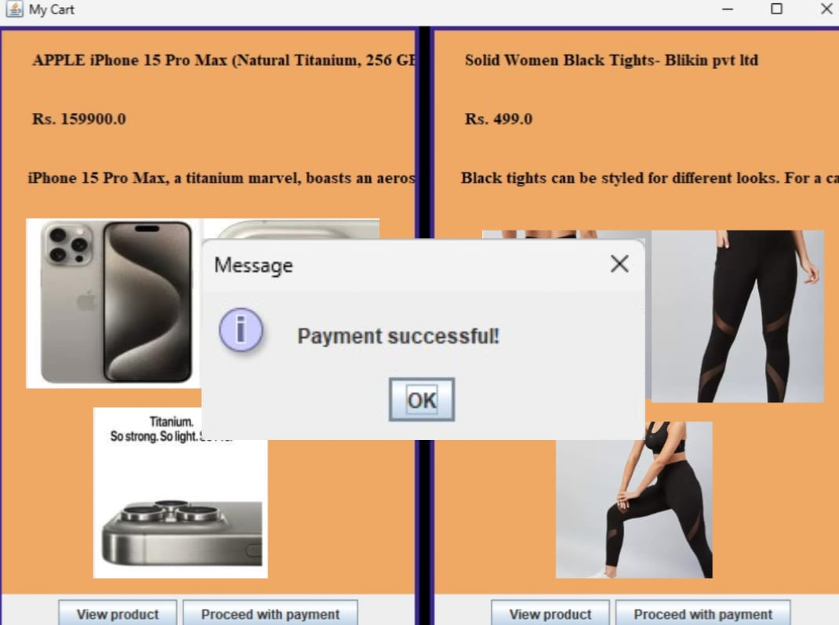

- DATABASES:

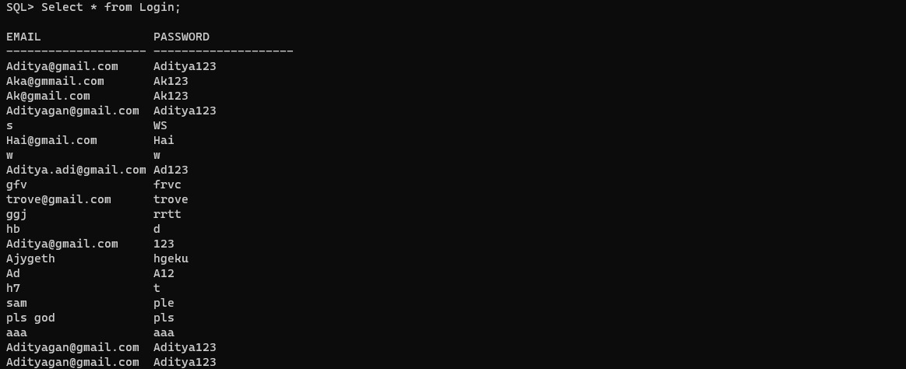
Login detais database:

Signup details database:
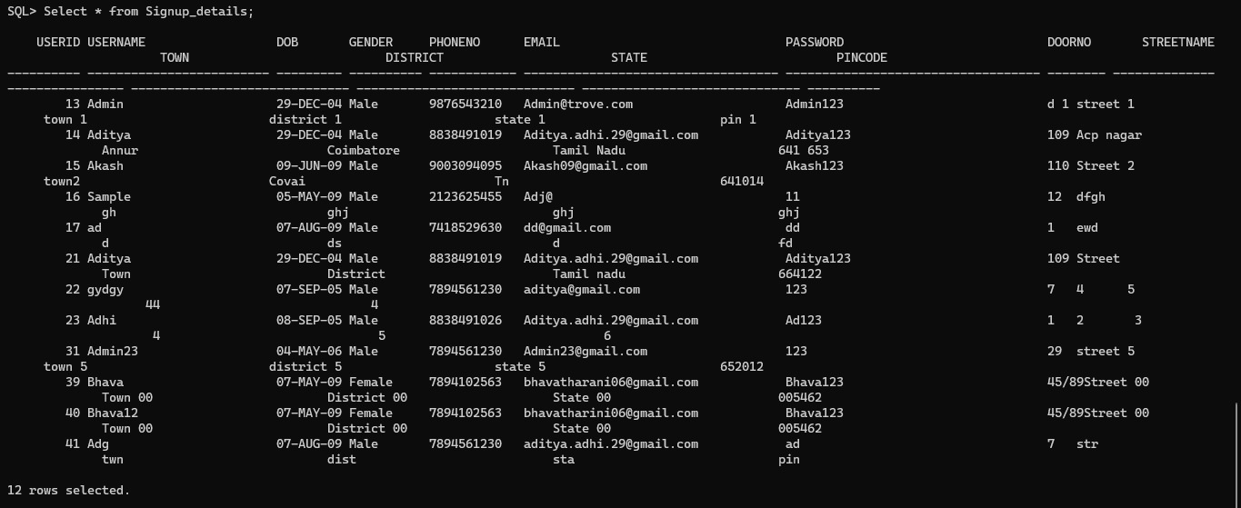

Products database:
